Welcome to Bradenton East Integrative Medicine, where we partner with you on your journey to optimal health!

Thank you for ch oosin g Bradenton East Integrative Medicine.
The providers want to give some important information on our practice prot ocols:

- Please make sure you check to see if our providers are in network with your insurance company. If we are out of network and you still want to see our providers make sure to ask about our discounted cash rates.
- Our hours of operation are 8:15 am to 5:00 pm Monday through Friday. We have a provider on call after hours and on the weekends, we may even be able to do a telehealth visit after hours if needed. Please call the office and follow the prompts, leave a message and the provider will call you back.
- We have set an appointment for your establishing visit. Please make sure you bring your state ID, insurance card, completed new patient paperwork and any medications and/or supplements you are taking in their original containers with you to your first visit. By bringing your medications in their original containers you help us to prevent medication errors, ensuring your safety, preventing harmful drug to drug interactions. If you have a living will or advance directive for medical decisions please bring this to your visit.
- We ask that you arrive at least 15 minutes prior to your appointment time so we can start your chart for your healthcare provider, helping to keep the patient flow on time. If you need to cancel or reschedule your appointment make sure this is done 24 hours prior to your visit to avoid a missed appointment fee. Since we reserve an extended time slot in the provider's schedule for your establishing visit our missed appointment fee is $100 for an establishing patient. Messages left on the office voice mail 24 hours before your visit are accepted for cancellation.
- We ask that you do not wear fragrance to your office visits; we have many patients with environmental sensitivities.
- The establishing visit is our time to collect all the information about your current and past medical history, your family's medical history and create a plan of care. We will schedule your physical (or wellness visit for Medicare patients), as well as any follow up visit needed, during the checkout process after your establishing

visit.

We do not do physicals or wellness exams at the first visit.

- We have a collaborative practice, where the Physicians work closely with our Nurse Practitioners to provide superior quality care that is easily accessible. If you establish are with one of the Nurse Practitioners, as is commonly scheduled, you will meet one of the physicians at the end of your visit. A physician is almost always in the clinic for consultation if needed during any visit. Our Nurse Practitioners also specialize in health maintenance visits, where we identify any quality of care gaps and make sure all of your necessary preventative screenings and immunizations are up to date. This scheduling process helps you to get to know two healthcare professionals within the practice who become the core of your healthcare team.
- We try to hold several appointment times available each day for sick calls. If you are experiencing any upper respiratory complaints our providers will see patients that are FULLY vaccinated for COVID. Patient’s that are not vaccinated can be seen via telehealth if experiencing any upper respiratory issues.
- Although our providers no longer do hospital care we have a close working relationship with a hospitalist service at Manatee Memorial Hospital, Lakewood Ranch Medical Center, Blake Hospital, Doctors Hospital and Sarasota Memorial Hospital.
- We now offer telehealth visits. Please note you must have the most up-to-date version of Google Chrome or Safari on your device with audio & visual capabilities to have a telehealth visit.

- We offer several lines of pharmaceutical grade nutritional supplements.
- We offer many different services here at Bradenton East that are not typically offered in other practices. We offer Bio-identical Hormone pellet therapy for both Men & Women, medically supervised weight loss programs, Mona Lisa Touch Laser Feminine rejuvenation treatment, IV therapy for Immune system boost and chelation. We also have affiliate providers that offer Facial rejuvenation & Podiatric care here in the office.
- Don't forget to check out our website @ www.beimonline.com and like us on Facebook!

INITIAL:

Version05/2021

BRADENTON EAST INTEGRATIVE MEDICINE

NEW PATIENT DEMOGRAPHIC FORM

Name: Date of Birth:

Sex (at birth): _

SSN: _ _ _ _ _ _ _ _ _ _ _ _ Race: Marital Status: _

Home Phone #: Cell#

Home Address: - - - - - - - - - - - - - - - - - - - - - - - - - - -
City: State: Zip Code: _

Email Address: - - - - - - - - - - - - - - - - - - - - - - - - - - -
Employer: _ _ _ _ _ _ _ _ _ _ _ _ _ _ _ _ Work #·. - - - - - -

Emergency Contact PHONE#
Relationship: _ _ _ _ _ _ _ _ _ _ _ _ _ _ _ _ _ _ _ _ _ _ _

Preferred Pharmacy: Phone# _ _ _ _ _ _ _ _

Name of previous (or current) Primary Care Physician:

Address: City: ST:

Phone#: - - - - - - - - - - -
Name and phone #o·f previous (or current) Specialist Physicians:

Insurance Company·. | _ | _ | _ | _ | _ | _ | _ | _ | _ | _ | _ | _ | _ | _ | _ _ _ _ _ _ _ _ _ _ _
Name of insured·. _ | _ | _ | _ | _ | _ | _ | _ | _ | _ | _ | _ | _ | _ | _ | _ _ _ _ _
Insurance ID #·. _ _ | _ | _ | _ | _ | _ | _ | _ | _ | _ | _ | _ | _ | _ | _
Group#: _ _ _ _ | _ | _ | _ | _ | _ | _ | _ | _ | _ | _ | _ | _ | _ | _ | _

KNOW YOUR INSURANCE-

Your insurance is a contract between you and your insurance company.

We want to inform you that your health insurance benefits may or may not cover specific services depending on your policy coverage, benefits, copays, co-insurance and/or deductible.

These services may include but are not limited to routine physical exams, ultrasound testing massage, acupuncture, specialty testing and laboratory services.

If your coverage denies any claim you will be financially responsible.
I understand it is my responsibility to understand my insurance and what it covers as long as I am a patient at Bradenton East Integrative Medicine.

Signature Date

Bradenton East Integrative Medicine Ethnicity Questionnaire
Please help us here at Bradenton East fulfill the requirements for meaningful use of an electronic medical record (as required by healthcare reform legislation). This requires us to collect additional demographic information regarding ethnicity. Please circle all categories that may apply to you.

American Indian or Alaska Native Asian
Black or African American Hispanic or Latino
Native Hawaiian or Other Pacific Islander White
Other

Please feel free to let us know any further details about tribal attachment, culture or national origin below:

Language Preference
English Japanese Spanish Chinese French Korean
German Other- - - - - - - - - - - - - - -

Patient Name DOB _

decline to participate

HIPPA Disclosure Agreement Bradenton East Integrative Medicine, P.A.

Patient Authorization for Disclosure of Information

Do we have permission to?

Leave the following information on your home answering machine or voice mail?

*Appointment Information | y | N
*Medical Information | y | N
*Billing Information | y | N
*Contact you at work | y | N

List family members of friends or personal care givers that you give permission to receive the following information about you:
Appointments: _ _ _ _ _ _ _ _ _ _ _ _ _ _ _ _ _ _ _ _ _ _ _ _ _ _

Medical or health information:

Billing/Payments:

I understand that the person or entity receiving authorized information is not a health plan or health care provider covered by federal privacy regulations, the authorized information may be disclosed by the recipient and may no longer be protected by federal or state law.

I understand that I may revoke this (hippa) authorization and that my refusal to sign in no way affects my treatment, payment, enrollment in a health plan or eligibility for benefits.

I have received a copy of the "Notice of Privacy Practices" to review and acknowledge that I may request a copy.

Signature:

Date: _

How did you find us? (Referral/Google/ Insurance /website) If referral name of person referring

MEDICAL HISTORY

CHECK ALL THAT APPLY:
□Abnormal Heart Rhythm □ Anemia □ Asthma □Autoimmune Disease
□ Bowel or Bladder Incontinence □Cancer--------- □Crohn's Disease
□ Deep Vein Thrombosis (blood clot) □ Diabetes □ Insulin resistance or borderline Diabetes
□Emphysema or Chronic Bronchitis (COPD) □ Fibromyalgia □ Food Allergies or Intolerance
□Headaches/Migraines □ Heart Attack □ Heart Disease □ High Blood Pressure □ High Cholesterol □ Hepatitis □ HIV/AIDS
□Irritable Bowel Syndrome □ Insomnia or other sleep disturbance □ Lupus □ Lyme Disease
□ Kidney Disease □ Osteoarthritis □ Osteoporosis □ Parkinson's Disease
□Pulmonary Embolism (clot in lung) □ Psoriasis □ Rheumatoid Arthritis
□ Seizures □Sleep Apnea □ Stomach Ulcers □ Stroke □ Thyroid Disease □ Ulcerative Colitis

□ Other- - - - - - - - - - - - - - - - - - - - -
SURGICAL HISTORY / HOSPITALIZATIONS

What: - - - - - - - - - - - - - - - - - - - Date: ---------
What: _ _ _ _ _ _ _ _ _ _ _ _ _ _ _ _ _ _ _ Dat e: _ _ _ _ _ _ _ _ _

What: _ _ _ _ _ _ _ _ _ _ _ _ _ _ _ _ _ _ _ Date: _

What:

- - - - - - - - - - - - - - - - - - -
Date:

What: _ _ _ _ _ _ _ _ _ _ _ _ _ _ _ _ _ _ _ Date: _ _ _ _ _ _ _ _ _

Do you currently have or had you had any Environmental Ex posures to chemicals/toxins/radiation?

Are you sensitive to any Environmental Chemicals? (i.e. perfumes/colognes, auto exhaust, MSG, etc)?

ACCIDENT HISTORY

Broken Bones- - - - - - - - - - - - - - - - - - - -
0ther Injuries_ _ _ _ _ _ _ _ _ _ _ _ _ _ _ _ _ _ _
Do you have a history of chronic infection or MRSA? □Yes □ No If Yes please explain_ _ _ _ _ _ _ _ _ _ _ _ _ _ _ _ _ _

MENTAL/ EMOTIONAL HEALTH HISTORY

CHECK ALL THAT APPLY:
□ Anxiety □ Bipolar Disorder □ Dementia/Memory Disorder □ Depression
□ Abuse: □ Physical □Emotional □ Sexual
(Treatment?)

PREVENTATIVE HEALTH HISTORY

Have you ever had a bone density (DEXA) test? □ Yes □ No
If yes what was the date? Was it normal? □ Yes □ No
Have you ever had a colonoscopy? □ Yes □ No
If yes what was the date? Was it normal? □Yes □ No
Have you ever had any other type of Colon cancer screening? □ Yes □ No
If yes what type? was the date? Was it normal? □ Yes □ No

ARE YOUR IMMUNIZATIONS UP TO DATE?
INFLUENZA □ Yes □ No Date

TETANUS ZOSTER  PREVNAR | - Yes  - Yes  - Yes | - No  - No  - No | Date  Date  Date
PNEUMOVAX | D Yes | □ No | Date
HEPATITIS B | D Yes | □ No | Date

HAVE YOU EVER BEEN SCREENED FOR HEPATITIS C? □ Yes □ No

If yes what was the date? _ _ _ _ _ _ Was it normal? □ Yes □ No
HAVE YOU EVER HAD GENETIC TESTING? □Yes □No

Genetic Disorders found

FEMALES ONLY:

When was your last menstrual period? _ _ _ _ _ _ _ _ _ _ _ _

At what age did you have your first menstrual period? _ _ _ _ _ _ _ _

Do you use a contraception method? □ Yes _ _ _ _ _ _ _ _ _ □ No

Pregnancy history: Number of pregnancies Number of children_ _ _ _ _

When was your last pap/pelvic exam? _ _ _ _ _ _ _ _ _ _ _

Do you have a history of any abnormal Pap smears? - if so what year? _ _ _ _ _ _ _

When was your last mammogram? (date) _ _ _ _ _ _ _ _ Was it normal? □Yes □ No Have you ever had an abnormal Mammogram? □ Yes (date) □ No
Do you have a history of a breast biopsy? □ Yes _ _ _ _ _ _ _ _ _ □ No
Family history of breast cancer? □ Yes_ _ _ _ _ _ _ □ No
Are you on any hormone replacement therapy □ Yes □ No
MALES ONLY:
When was your last Prostate exam? _ _ _ _ _ _ _ _
Have you ever had a PSA test? □Yes □No

When was the last one? ------
Do you have any of the following:
Was it normal? □Yes □No

D low sex drive □ erectile dysfunction/difficulties □ mood problems □ fatigue or low energy Are you on Testosterone replacement therapy? □Yes □No

SOCIAL HISTORY
What is your Marital Status? □ Single □Married □ Divorced □ Widowed □Other long term partnership
Do you live alone? □Yes □No If no who do you live with? _ _ _ _ _ _ _ _ _ _ _ _
Who is your emergency contact/contact# _ _ _ _ _ _ _ _ _ _ _ _ _ _ _ _ _ _
Are there safety concerns at home? □Yes □No _ _ _ _ _ _ _ _ _ _ _ _ _ _ _ _
Do you have a living will or DPOA/ Do we have a copy? □Yes □No
Do you have any History of Domestic Abuse? □Yes □No _ _ _ _ _ _ _ _ _ _ _ _ _

What is your Occupation: (If retired what was your former occupation?)

Are you a full or Part time (how many months in Florida) resident of Florida? - - - - - - - - - - - - - - - - - - - - -
Do you use Alcohol? □Yes □ No If yes, then how often and how much?

Any history of alcohol abuse or alco holism? □ Yes □ No
Do you use Drugs other than prescription drugs? □ Yes □ No If yes, then what drugs and how often?

Do you have any history of drug abuse?

Do you currently follow a Specific Diet or Nutritional program? □ Yes □ No If so which one?

Do you use caffeine? □ Yes □ No If so how often? _ Do you Exercise? □ Yes □ No If so what type and how often?

Do you use Tobacco? (smoke or chew) □Yes □No

If yes, then how much and for how long? _ _ _ _ _ _ _ _ _ _ _ _ _ _ _ _ _ _ _

In no, then do you have a history of tobacco use? □ Yes □ No
If yes, then how many years did you smoke/chew? How long ago did your quit?

Do you or have you had any significant secondhand smoke exposure? □ Yes □ No Do you use a seatbelt? □ Yes □ No
FAMILY HISTORY
Mother: □ Alive: age _ _ _ _ _ □ Deceased@ age_ _ _ _ _
Medical hist ory: □ Diabetes □ Heart Problems □ Cancer □ Stroke □Hypertension Other _
Father: □Alive: age □ Deceased@ age_ _ _ _ _
Medical history: □Diabetes □Heart Problems □Cancer □ Stroke □Hypertension Other- - - - - - - - - - - - -
Brother(s)? Medical problems?

Sister(s)? Medical problems? _ _ _ _ _ _ _ _ _ _ _ _ _ _ _ _ _ _ _ _ _ _

ALLERGIES

Medication: _ _ _ _ _ _ _ _ _ _ _ Type of Reaction: _

Medication: _ _ _ _ _ _ _ _ _ _ _ Type of Reaction : _ _ _ _ _ _ _ _ _ _ _ _

Medication: _ _ _ _ _ _ _ _ _ _ _ Type of React ion: _ _ _ _ _ _ _ _ _ _ _ _

Food:_ _ _ _ _ _ _ _ _ _ _ _ _ Type of Reaction: _ _ _ _ _ _ _ _ _ _ _ _

Food:_ _ _ _ _ _ _ _ _ _ _ _ _ Type of Reaction: _ _ _ _ _ _ _ _ _ _ _ _
Food : Type of React ion: _

Other: _ _ _ _ _ _ _ _ _ _ _ _ _Type of Reaction: _

Do you have any current concerns?

BRADENTON EAST INTEGRATIVE MEDICINE NOTICE OF PRIVACY PRACTICES

THIS NOTICE DESCRIBES HOW MEDICAL INFORMATION ABOUT YOU MAY BE USED AND DISCLOSED
AND HOW YOU CAN GET ACCESS TO THIS INFORMATION. PLEASE REVIEW IT CAREFULLY.

If you have any questions about this Notice please contact
our Privacy Officer who is HEATHER JOHNSON

This Notice of Privacy Practices describes how we may use and disclose your protected health information to carry out treatment, payment or health care operations and for other purposes that are permitted or required by law. It also describes your rights to access and control your protected health information. "Protected health information" is information about you, including demographic information, that may identify you and that relates to your past, present or future physical or mental health or condition and related health care services.

We are required to abide by the terms of this Notice of Privacy Practices. We may change the terms of our notice, at any time. The new notice will be effective for all protected health information that we maintain at that time. Upon your request, we will provide you with any revised Notice of Privacy Practices. You may request a revised version by accessing our website, or calling the office and requesting that a revised copy be sent to you in the mail or asking for one at the time of your next appointment.

1. USES AND DISCLOSURES OF PROTECTED HEALTH INFORMATION

Your protected health information may be used and disclosed by your physician, our office staff and others outside of our office who are involved in your care and treatment for the purpose of providing health care services to you. Your protected health information may also be used and disclosed to pay your health care bills and to support the operation of your physician's practice.
Following are examples of the types of uses and disclosures of your protected health information that your physician's office is permitted to make. These examples are not meant to be exhaustive, but to describe the types of uses and disclosures that may be made by our office.

Treatment: We will use and disclose your protected health information to provide, coordinate, or manage your health care and any related services. This includes the coordination or management of your health care with another provider. For example, we would disclose your protected health information, as necessary, to a home health agency that provides care to you. We will also disclose protected health information to other physicians who may be treating you. For example, your protected health information may be provided to a physician to whom you have been referred to ensure that the physician has the necessary information to diagnose or treat you. In addition, we may disclose your protected health information from time-to-time to another physician or health care provider (e.g., a specialist or laboratory) who, at the request of your physician, becomes involved in your care by providing assistance with your health care diagnosis or treatment to your physician.

Payment: Your protected health information will be used and disclosed, as needed, to obtain payment for your health care services provided by us or by another provider. This may include

certain activities that your health insurance plan may undertake before it approves or pays for the health care services that we recommend for you such as: making a determination of eligibility or coverage for insurance benefits, reviewing services provided to you for medical necessity, and undertaking utilization review activities. For example, obtaining approval for a hospital stay may require that your relevant protected health information be disclosed to the health plan to obtain approval for the hospital admission.

Health Care Operations: We may use or disclose, as needed, your protected health information in order to support the business activities of your physician's practice. These activities include, but are not limited to, quality assessment activities, employee review activities, training of medical students, licensing, fundraising activities, and conducting or arranging for other business activities.

We will share your protected health information with third party "business associates" that perform various activities (for example, billing or transcription services) for our practice. Whenever an arrangement between our office and a business associate involves the use or disclosure of your protected health information, we will have a written contract that contains terms that will protect the privacy of your protected health information.

We may use or disclose your protected health information, as necessary, to provide you with information about treatment alternatives or other health-related benefits and services that may be of interest to you. You may contact our Privacy Officer to request that these materials not be sent to you.

We may use or disclose your demographic information and the dates that you received treatment from your physician, as necessary, in order to contact you for fundraising activities supported by our office. If you do not want to receive these materials, please contact our Privacy Officer and request that these fundraising materials not be sent to you.

Other Permitted and Required Uses and Disclosures That May Be Made Without Your Authorization or Opportunity to Agree or Object

We may use or disclose your protected health information in the following situations without your authorization or providing you the opportunity to agree or object. These situations include:

Required by Law: We may use or disclose your; protected /health information to the extent that the use or disclosure is required by law. The use or disclosure will be made in compliance with the law and will be limited to the relevant requirements of the law. You will be notified, if required by law, of any such uses or disclosures.

Public Health: We may disclose your protected health information for public health activities and purposes to a public health authority that is permitted by law to collect or receive the information. For example, a disclosure may be made for the purpose of preventing or controlling disease, injury or
disability.

Communicable Disease.: We may disclose your protected health information, if authorized by law, to a person who may have been exposed to a communicable disease or may otherwise be at risk of contracting or spreading the disease or condition.

Health Oversight: We may disclose protected health information to a health oversight agency for activities authorized by law, such audits, investigations, and inspections. Oversight agencies seeking this information include governmental agencies that oversee the health care system, government benefit programs, other government regulatory programs and civil rights laws.

Abuse or Neglect: We may disclose your protected health information to a public health authority that is authorized by law to receive reports of child abuse or neglect. In addition, we may disclose your protected health information if we believe that you have been a victim of abuse, neglect or domestic violence to the governmental entity or agency authorized to receive such information. In this case, the disclosure will be made consistent with the requirements of applicable federal and state laws.

Food and Drug Administration: We may disclose your protected health information to a person or company required by the Food and Drug Administration for the purpose of quality, safety, or effectiveness of FDA-regulated products or activities including to report adverse events, product defects or problems, biologic product deviations, to track products; to enable product recalls; to make repairs or replacements, or to conduct post marketing surveillance, as required.

Legal Proceedings: We may disclose protected health information in the course of any judicial or administrative proceeding, in response to an order of a court or administrative tribunal (to the extent that such disclosure is expressly authorized), or in certain conditions in response to a subpoena, discovery request or other lawful process.

law Enforcement: We may also disclose protected health information so long as applicable legal requirements are met for law enforcement purposes. These low enforcement purposes include (1) legal processes and otherwise required by low, (2) limited information requests for identification and location

purposes, (3) pertaining to victims of a crime, (4) suspicious that death has occurred as a result of criminal conduct, (5) in the event that a crime occurs on the premises of our practice, and (6) medical emergency (not on our practice's premises) and it is likely that a crime has occurred.

Coroners, Funeral Directors, and Organ Donation: We may disclose protected health information to a coroner or medical examiner for identification purposes, determining cause of death or for the coroner or medical examiner to perform other duties authorized by law. We may also disclose protected health information to a funeral director, as authorized by law, in order to permit the funeral director to carry out their duties. We may disclose such information in reasonable anticipation of death. Protected health information may be used and disclosed for cadaveric organ, eye or tissue donation purposes.

Research: We may disclose your protected health information to researchers when their research has been approved by an institutional review board that has reviewed the research proposal and established protocols to ensure the privacy of your protected health information.

Criminal Activity: Consistent with applicable federal and state laws we may disclose your protected health information, if we believe that the use or disclosure is necessary to prevent or lessen a serious and imminent

threat to the health or safety of a person or the public. We may also disclose protected health information

if it is necessary for law enforcement authorities to identify or apprehend an individual.

Military Activity and National Security: When the appropriate conditions apply, we may use or disclose protected health information of' individuals who are Armed Forces personnel (1) for activities deemed necessary by appropriate military command authorities; (2) for the purpose of a determination by the department of veterans affairs of your eligibility for benefits, or (3) to foreign military authority if you are a member of' that foreign military services. We may also disclose your protected health information to authorized federal officials, for conducting national security and intelligence activities, including for the provision of protective services to the President or others legally authorized.

Uses and Disclosures of Protected Health Information Based upon Your Written Authorization

Workers' Compensation: We may disclose your protected health information as authorized to comply

with workers' compensation laws and other similar legally-established programs.

Inmates: We may use or disclose your protected health information if you are on inmate of a correctional facility and your physician created or received your protected health information in the course of providing care to you.

Other uses and disclosures of your protected health information will be made only with your written authorization; unless otherwise permitted or required by law as described below. You

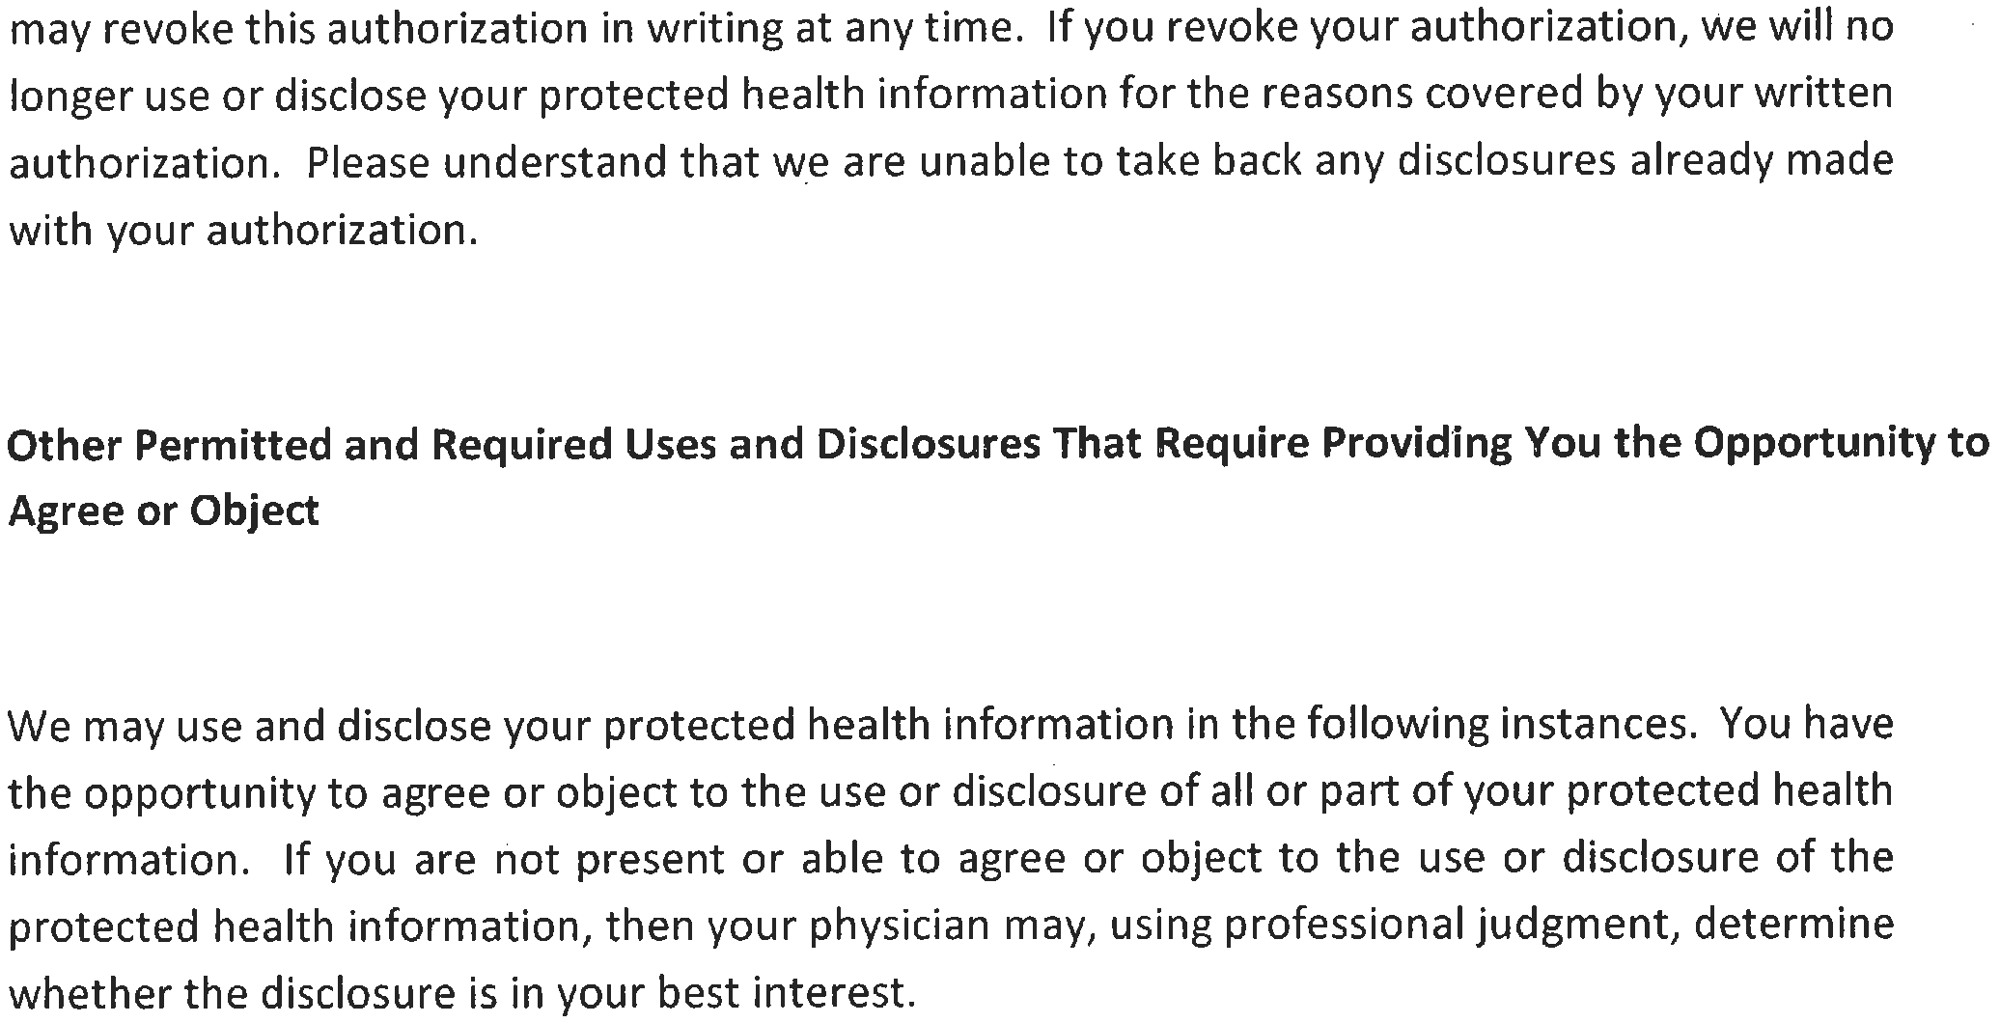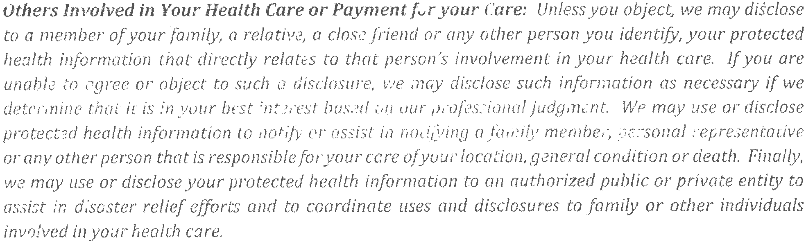

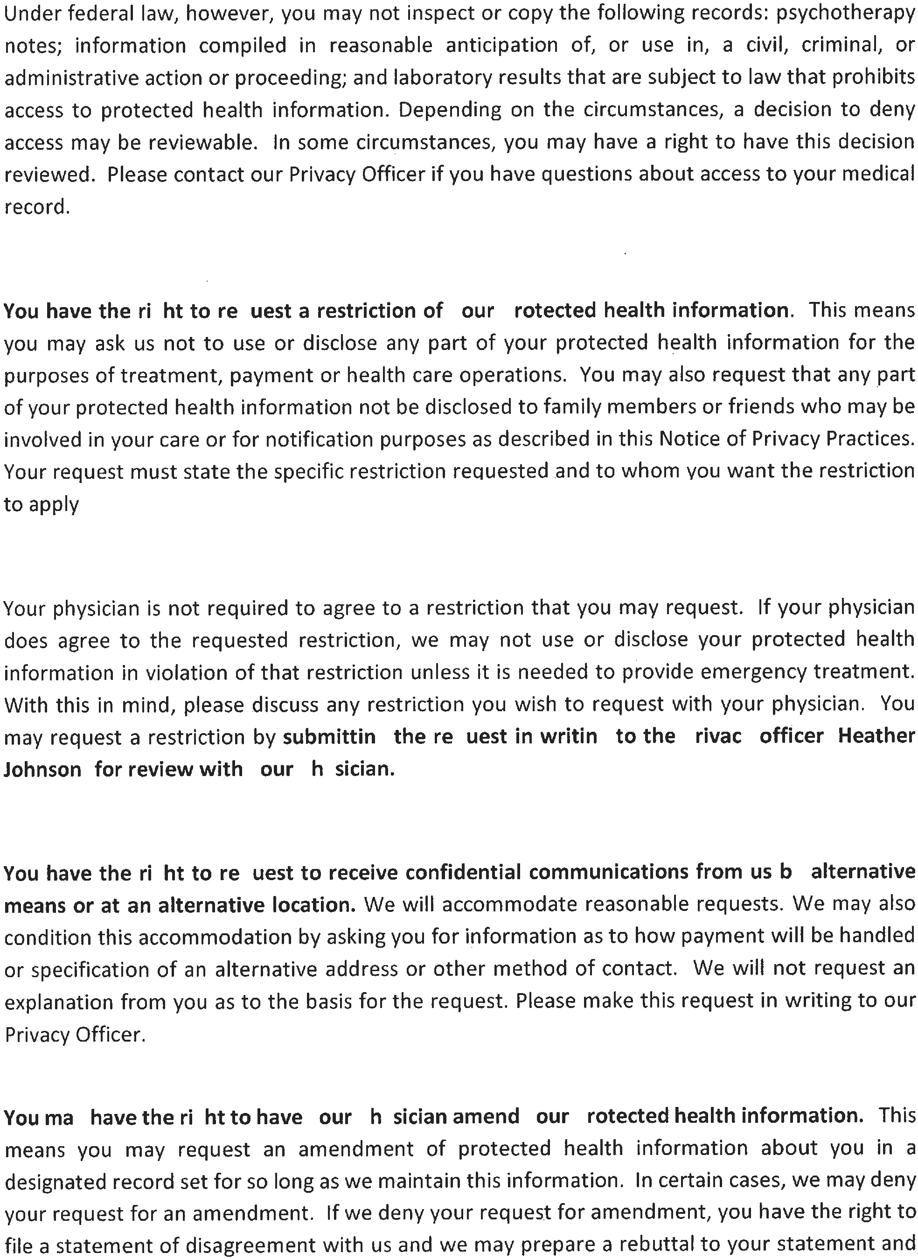

will provide you with a copy of any such rebuttal. Please contact our Privacy Officer if you have questions about amending your medical record.

You have the right to receive an accounting of certain disclosures we have made, if an y, of your protect ed health information. This right applies to disclosures for purposes other than treatment, payment or health care operations as described in this Notice of Privacy Practices. It excludes disclosures we may have made to you if you authorized us to make the disclosure, for a facility directory, to family members or friends involved in your care, or for notification purposes, for national security or intelligence, to law enforcement (as provided in the privacy rule) or correctional facilities, as part of a limited data set disclosure. You have the right to receive specific information regarding these disclosures that occur after April 14, 2003. The. right to receive this information is subject to certain exceptions, restrictions and limitations.

You have the right to obtain a paper copy of this notice from us, upon request, even if you have agreed to accept this notice electronically.
3. COMPLAINTS

You may complain to us or to the Secretary of Health and Human Services if you believe your privacy rights have been violated by us. You may file a complaint with us by notifying our Privacy Officer of your complaint. We will not retaliate against you for filing a complaint.

You may contact our Privacy Officer, Heather Johnson at (941)727-1243 or beim6120@gmail.com for further information about the complaint process.

This notice was published and becomes effective on 9/1/2013.

I have read the Privacy Notice and understand my rights contained in the notice.

By way of my signature, I provide Bradenton East Integrative Medicine with my authorization and consent to use and disclosed my protected health care information for the purposes of treatment, payment and health care operations as described in the Privacy Notice.

Patient's Name (print) Date

Patient's Signature Date

Authorized Facility Signature Date

REQUEST TO RELEASE MEDICAL RECORDS TO:
BRADENTON EAST INTEGRATIVE MEDICINE, PA
8614 EAST STATE ROAD 70 SUITE 200 BRADENTON, FL 34202
941-727-1243
FAX: 941-751-9039

KAREN BRAINARD, MD SAMANTHA NOTMAN, DO
DEB COUPLAND, APRN CAROL LEWIS, APRN___
DEREK SISK, APRN_____ BRIDGETT EDWARDS, APRN____

FROM:
NAME OF HEALTHCARE PROVIDER/PHYSICAN

STREET ADDRESS

CITY, STATE & ZIP
PHONE ( ) FAX ( )

PRINT PATIENT’S FULL NAME

/_ /_ DATE OF BIRTH

_
SIGNATURE OF PATIENT OR GUARDIAN DATE

I HEREBY AUTHORIZE USE OR DISCLOSURE OF PROTECTED HEALTH INFORMATION ABOUT ME AS DESCRIBED BELOW FOR THE PURPOSE OF CONTINUITY OF CARE

COMPLETE MEDICAL RECORDS _ LAB TESTS
X-RAYS EKG/ECG/CARDIAC STUDIES
CONSULT REPORTS
I UNDERSTAND THAT THE INFORMATION IN MY HEALTH RECORD MAY INCLUDE INFORMATION RELATING TO SEXUALLY TRANSMITTED DISEASE, AQUIRED IMMUNODEFICIENCY SYNDROME (AIDS), OR HUMAN IMMUNODEFICIENCY VIRUS (HIV). IT MAY ALSO INCLUDE INFORMATION ABOUT BEHAVIORAL OR MENTAL HEALTH SERVICES, AND TREATMENT FOR ALCOHOL AND DRUG ABUSE OR SELF-PAID SERVICES. YOU ARE HEREBY SPECIFICALLY AUTHORIZED TO RELEASE ALL INFORMATION OR MEDICAL RECORDS RELATING TO SUCH DIAGNOSIS, TESTING, OR TREATMENT, UNLESS SPECIFICALLY EXCLUDED BELOW:

THIS AUTHORIZATION WILL EXPIRE ONE YEAR FROM THE DATE OF SIGNING.
THE PATIENT MAY REVOKE THIS AUTHORIZATION AT ANYTIME UPON WRITTEN REQUEST.
I ACKNOWLEDGE THAT THE DISCLOSED INFORMATION MAY NO LONGER BE PROTECTED BY THE PRIVACY PRACTICES OF THIS PRACTICE.

