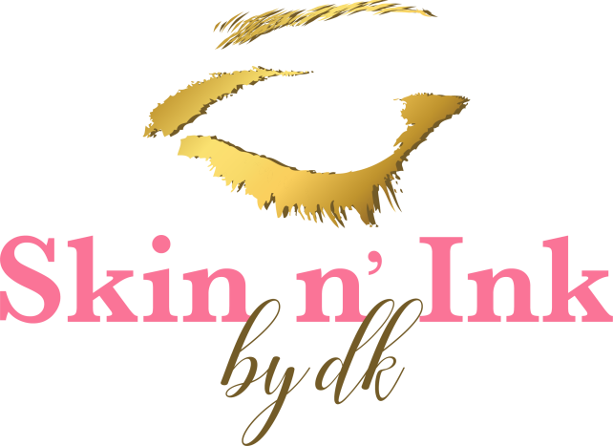

Eyebrows
Microblading Special  Using a tool to get the hair stroke look | $275
Powdery Soft Look | $400
Designer Brows: Microblading  A feathering, embroidering and hair stroke technique | Call for Special
Designer Brows: Ombre  Consists of 2 or more shades to give the ombre effect | Call for Special

Eyeliner
Upper Only  Thick or thin line enhancing the upper lid | $300
Lower Only  Thin line enhancing the lower lid | $150
Upper and Lower (at the same time)  Thick or thin line enhancing both the upper and lower lid | $400

Designer Eyeliner
Star Dust  Upper lid only | Call for Special
Thick Liner
A thicker shadowing with lid enhancement for the upper and/or lower eyelid giving it the smokey look

Lips
Lip Liner Blend | $399
Full Lip Color  Shading with liner | $550

